CS 3050 Homework # 5. Name :

Submitted to Blackboard, due at 11:59pm on April 23, 2019.

- Give an adjacency-list representation for a binary tree on 6 vertices. Give an equivalent adjacency-matrix representation. Assume that vertices are numbered from 1 to 6 as in a binary heap.

0 | 1 | 2 | 3 | 4 | 5 | 6
1 | 0 | 1 | 1 | 0 | 0 | 0
2 | 0 | 0 | 0 | 1 | 1 | 0
3 | 0 | 0 | 0 | 0 | 0 | 1
4 | 0 | 0 | 0 | 0 | 0 | 0
5 | 0 | 0 | 0 | 0 | 0 | 0
6 | 0 | 0 | 0 | 0 | 0 | 0

1 | → | 2 | → | 3
2 | → | 4 | → | 5
3 | → | 6
4
5
6

2. Consider the following undirected graph G:

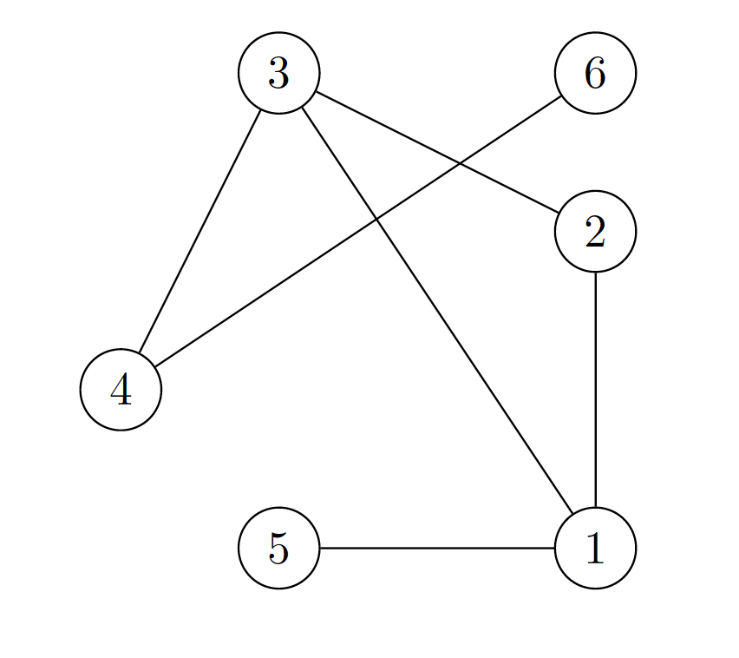
(a) Give the adjacency matrix representation of G.
0 | 1 | 2 | 3 | 4 | 5 | 6
1 | 0 | 1 | 1 | 1 | 1 | 0
2 | 1 | 0 | 1 | 0 | 0 | 0
3 | 1 | 1 | 0 | 3 | 0 | 0
4 | 0 | 0 | 1 | 0 | 0 | 1
5 | 1 | 0 | 0 | 0 | 0 | 0
6 | 0 | 0 | 0 | 0 | 0 | 0

(b) Give the adjacency list representation of G for every vertex.

1 | → | 2 | → | 3 | → | 5
2 | → | 3 | → | 1
3 | → | 2 | → | 1 | → | 4
4 | → | 3 | → | 6
5 | → | 1
6 | → | 4

(c) Give the search ordering by running the Breadth First Search (BFS) algorithm on G with 3 as the source vertex.

Output: 3,1,2,4,5,6

(d) Give the search ordering generated by running the Depth First Search (DFS) algorithm on G with 3 as the source vertex. For each vertex in the DFS tree, please also indicate the start time and the finish time generated by the DFS algorithm.
output | 2 | 5 | 1 | 6 | 4 | 3
Time start | 3 | 5 | 2 | 9 | 8 | 11
Time finish | 4 | 6 | 7 | 10 | 11 | 12

3. Make a 3-by-3 chart with row and column labels WHITE, GRAY, and BLACK. In each cell (i,j), indicate whether, at ANY point during a depth-first search of a directed graph, there can be an edge from a vertex of color i to a vertex of color j . For each possible edge, indicate what edge types it can be (Tree edge, Back edge, Forward edge, or Cross edge). Make a second such chart for depth-first search of an undirected graph.
 | White | Gray | Black
White | Tree edge  Forward edge  Back edge  Cross edge | Cross edge  Back edge | Cross edges
Gray | Forward edge  Tree edge | Tree edge  Back edge  Forward edge | Tree edge  Forward edge  Cross edge
Black |  | Back edge  Cross edge | Tree edge  Forward edge  Back edge  Cross edge

 | White | Gray | Black
White | Tree  Back | Tree  Back
Gray | Tree  Back | Tree  Back | Tree  Back
Black |  | Tree  Back | Tree  Back

4. Show the ordering of vertices produced by topological-sort of the following graph (start the DFS at node r):

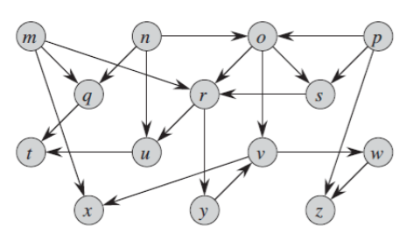

output | T | U | Z | W | X | V | Y | R | Q | M | S | O | N | P
Time start | 3 | 2 | 9 | 8 | 12 | 7 | 6 | 1 | 18 | 17 | 23 | 22 | 21 | 27
Time finish | 4 | 5 | 10 | 11 | 13 | 14 | 15 | 16 | 19 | 20 | 24 | 25 | 26 | 28

P →O→R→U→T
R→Y→V→W→Z
V→X
O→S→R
O→R
P→S
P→Z

N→ O→R→U→T
R→Y→V→W→Z
V→X
O→S→R
O→R
N→U→T
N→Q→T

M→Q→T
M→R→U→T
Y→V→W→Z
V→X
M→X

T

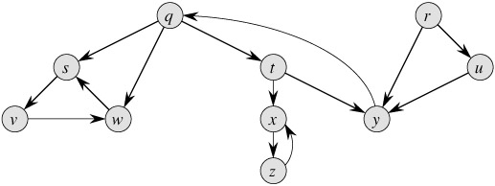
5. Show how the procedure STRONGLY-CONNECTED-COMPONENTS works on the following graph. Specifically, show the finishing times computed in line 1 and the forest produced in line 3. Assume that the loop of lines 5-7 of DFS considers vertices in alphabetical order and that the adjacency lists are in alphabetical order. (from the textbook problem 22.5-2)

